Software Requirements
Document Title: | M4 Hardware I/O test
Document Number: | ED-1330
Document Revision: | 0.03
Project Number: | 21344

Revision History
Revision | Entered by |  | Date | Title or Description
V0.01 |  | Al Liebel | 11SEP14 | Initial Revision – Modified for M4 Controller.
V0.02 |  | Al Liebel | 12DEC14 | Added provisions for CAN Loopback test
V0.03 |  | Al Liebel | 15JAN15 | Updates to EEPROM tests
Published by:
Bobcat Company
403 Airport Road
Bismarck, ND 58504

Table of Contents

1 PRODUCT DESCRIPTION AND REFERENCES 4
1.1 Overview 4
1.2 Contact Information 4
1.3 References 4
1.3.1 Bobcat Standards 4
1.4 Acronyms and Definitions 4
1.4.1 Acronyms 4
1.4.2 Definitions 4
1.5 Product Summary 5
2 SPECIFICATIONS AND BLOCK DIAGRAM 6
2.1 CAN interface 6
2.2 DV address map for hardware I/O test functions 7
2.3 Access level change procedure 10

PRODUCT DESCRIPTION AND REFERENCES

Overview
This document describes or references the electronic requirements for a Bobcat product. The requirements in this document shall be limited to that of the electronic product and shall not describe requirements for any other of its systems or components.

Contact Information

Any questions regarding this document should be directed to Bobcat product engineering for further information or clarification.

References

Bobcat Standards

Acronyms and Definitions

Acronyms
ECU (Electronic Control Unit)
DV (Design Validation)

Definitions

Product Summary
For manufacturing and/or service use, the following will be provided in each ECU.

- The ability to monitor the state of all inputs and outputs.
- The ability to place an ECU into a special test mode. In this mode, the application functionality will stop executing and the output commands will come from an external test tool.
- Access to select functionality.

This document describes how this will be done using the Bobcat "DV table" concept provided in many Bobcat controls.

SPECIFICATIONS AND BLOCK DIAGRAM
The interface to this test functionality will be provided via the indirect 16-bit memory read/write facility provided in many of the Bobcat ECU platforms.

CAN interface
The test tool will read and write to DV addresses using the following "Bobcat J1939 Proprietary A" messages.
29-bit CAN identifier (J1939 Proprietary A in PDU1 format)
Priority  (3-bits) | R  (1-bit) | DP  (1-bit) | PF  (8-bits) | PS  (8-bits) | SA  (8-bits)
6 | 0 | 0 | 0xEF | destination  address | Source  Address

The address of the test tool shall be 0xF9.
The address of the ECU will vary dependent upon application software.

Read Word Command
ID: | J1939 Proprietary A  source address (tool)  destination address (ECU)

Data:  (64-bits) | Msg ID  (8-bits) | Address  (16-bits)  LSByte 1st | Not used  (40-bits)
Data:  (64-bits) | 0x07 | DV address

Read Word Response
ID: | J1939 Proprietary A  source address (ECU)  destination address (tool)

Data:  (64-bits) | Msg ID  (8-bits) | Address  (16-bits)  LSByte 1st | Data  (16-bits)  LSByte 1st | Not used  (24-bits)
Data:  (64-bits) | 0x07 | DV address | data

Write Word Command
ID: | J1939 Proprietary A  source address (tool)  destination address (ECU)

Data:  (64-bits) | Msg ID  (8-bits) | Address  (16-bits)  LSByte 1st | Data  (16-bits)  LSByte 1st | Not used  (24-bits)
Data:  (64-bits) | 0x0A | DV address | data

DV address map for hardware I/O test functions
DV address | DV name | Access Level |  | Description
10 | HWT_SUPPORT_LEVEL | -- | R | Hardware test support levels this ECU is capable of.  0-none  1-L1 capable (monitor)  2-L2 capable (monitor / output override)
11 | HWT_BASE_ADDRESS | -- | R | The base "DV address" of the hardware test functionality.
HWT_BASE_ADDRESS | HWT_ACCESS_LEVEL | L1 | R | 1-L1 monitor  2-L2 monitor / output override
+1 | HWT_ACCESS_SEED | L1 | R | See section 2.3 Access level change procedure for a description of how these locations are used to change the "HWT_ACCESS_LEVEL".
+2 | HWT_ACCESS_KEY | L1 | W
+3 | HWT_DIN_QTY | L1 | R | The value of the HWC_DIN_QTY enumeration for this ECU.
+4 | HWT_DIN_BASE | L1 | R | First DV address of the digital input data.
+5 | HWT_ADC_QTY | L1 | R | The value of the HWC_ADC_QTY enumeration for this ECU.
+6 | HWT_ADC_BASE | L1 | R | First DV address of the analog input data.
+7 | HWT_FIN_QTY | L1 | R | The value of the HWC_FIN_QTY enumeration for this ECU.
+8 | HWT_FIN_BASE | L1 | R | First DV address of the frequency input data.
+9 | HWT_DOUT_QTY | L1 | R | The value of the HWC_FIN_QTY enumeration for this ECU.
+10 | HWT_DOUT_BASE | L1 | R | First DV address of the digital output data.
+11 | HWT_PWM_QTY | L1 | R | The value of the HWC_PWM_QTY enumeration for this ECU.
+12 | HWT_PWM_BASE | L1 | R | First DV address of the pulse width modulated output data.
+13 | HWT_GAUGE_QTY | L1 | R | The value of the HWC_GAUGE_QTY enumeration for this ECU.
+14 | HWT_GAUGE_BASE | L1 | R | First DV address of the gauge output data.
+15 | HWT_FCALL_BASE | L1 | R | First DV address of the function call HWT section.
HWT_DIN_BASE | HWT_DIN_ BANK_0 | L1 | R | Each address contains a bank of 16 digital inputs. Each bit maps to a digital input channel as follows.  BANK_0 (ch16:ch15:ch14:ch13:ch12:ch11:ch10:ch9:ch8:ch7:ch6:ch5:ch4:ch2:ch1)  BANK_m (0:0:0:…:chn:Chn-1:….)  Refer to Appendix A for channel mapping
… | … | L1 | R
HWT_DIN_BASE +  (HWT_DIN_QTY/16) | HWT_DIN_BANK_m | L1 | R
HWT_ADC_BASE | HWT_ADC_GETVALUE_0 | L1 | R | One address for 10-bit A2D value for each analog input channel.
… | … | L1 | R
HWT_ADC_BASE +  (HWT_ADC_QTY-1) | HWT_ADC_GETVALUE_n | L1 | R
HWT_FIN_BASE | HWT_FIN_GETPERIODUS_LSW_0 | L1 | R | Two addresses for the period in uSec for each frequency input channel.
HWT_FIN_BASE+1 | HWT_FIN_GETPERIODUS_MSW_0 | L1 | R
… | … | L1 | R
HWT_FIN_BASE +  2* (HWT_FIN_QTY-1) | HWT_FIN_GETPERIODUS_LSW_n | L1 | R
HWT_FIN_BASE +  2* (HWT_FIN_QTY) -1 | HWT_FIN_GETPERIODUS_MSW_n | L1 | R
HWT_DOUT_BASE | HWT_DOUT_BANK_0 | L1  L2 | R  R/W | Each address contains a bank of 16 digital outputs. Each bit maps to a digital output channel as follows.  BANK_0 (ch16:ch15:ch14:ch13:ch12:ch11:ch10:ch9:ch8:ch7:ch6:ch5:ch4:ch2:ch1)  BANK_m (0:0:0:…:chn:Chn-1:….)  Read  Gets current value of the digital output bank.  Write  Sets the current value of the digital output bank.
… | … | L1  L2 | R  R/W
HWT_DOUT_BASE +  (HWT_DOUT_QTY/16) | HWT_DOUT_BANK_m | L1  L2 | R  R/W
HWT_PWM_BASE | HWT_PWM_RATIO16_0 | L1  L2 | R  R/W | One address for each PWM channel.  Read:  Gets the current value of the PWM ratio (0xFFFF = 100% duty cycle)  Write  Sets the current value of the PWM ratio
… | … | L1  L2 | R  R/W
HWT_PWM_BASE +  (HWT_PWM_QTY-1) | HWT_PWM_RATIO16_n | L1  L2 | R  R/W
HWT_PWM_BASE +  (HWT_PWM_QTY) | HWT_PWM_FREQUENCY_0 | L1  L2 | R  R/W | One address for each PWM channel.  Read:  Gets the current value of the PWM frequency (Hz)  Write  Sets the current value of the PWM frequency
… | … | L1  L2 | R  R/W
HWT_PWM_BASE +  2*(HWT_PWM_QTY-1) | HWT_PWM_ FREQUENCY_n | L1  L2 | R  R/W
HWT_GAUGE_BASE | HWT_GAUGE_POSITION_0 | L1  L2 | R  R/W | Not applicable to M4 Design
… | … | L1  L2 | R  R/W | Not applicable to M4 Design
HWT_GAUGE_BASE +  (HWT_GAUGE_QTY-1) | HWT_ GAUGE_POSITION _n | L1  L2 | R  R/W | Not applicable to M4 Design
HWT_FCALL_BASE | HWT_RESET_FORCE | L2 | W | Forces a processor reset.  Write value passes arguments for startup mode  LSByte - bb_smode argument  MSByte -ap_smode argument
+1 | HWT_RESET_ SMODES | L2 | R | LSByte – bb_smode value  MSByte - ap_smode value
+2 | HWT_MCU_HARDWARE_ID |  | R | Gets value of the controller HW_ID inputs.  (0:0:0:0:0:0:0:0:0:id6:id5:id4:id2:id1:id0)
+3 | HWT_MCU_POWER_HOLD | L2 | R/W | Read:  Gets the current state of the power hold output.  Write  Sets the state of the power hold output.
+4 | HWT_CLOCK_US | L2 | R | Clock value in uSec
+5 | HWT_CLOCK_MS | L2 | R | Clock value in mSec
+6 | HWT_CLOCK_S | L2 | R | Clock value in Sec
+7 | --- | L2 | R | ---
+8 | HWT_NVM_EEPROM_STATUS | L2 | R | Value returned from the last call to a NVM EEPROM function from this hardware test module..  NVM_OK=0, NVM_BUSY=1, NVM_NOTAVAIL=2, NVM_RANGE=3, NVM_BATT=4
+9 | HWT_NVM_EEPROM_SECTION | L2 | R/W | EEPROM section accessed by NVM EEPROM function calls.  E0 = 0x0001 (Manufacturing EEPROM)  E10 = 0x0400 (Application EEPROM)
+10 | HWT_NVM_EEPROM_ADDRESS | L2 | R/W | EEPROM address accessed by NVM EEPROM function calls.
+12 | HWT_NVM_EEPROM_READ_UINT16 | L2 | R | Read data from the EEPROM based on data previously written to section and address.
+13 | HWT_NVM_EEPROM_WRITE_UINT16 | L2 | W | Writes the value written to this location to the EEPROM based on data previously written to section, address.
+14 | HWT_NVM_EEPROM_CHECKSUM | L2 | R | Returns the uint16 sum of all EEPROM locations defined by section.
+15 | HWT_NVM_EEPROM_TCMD | L2 | W | A non-zero value causes the application EEPROM write/read test to begin execution.  This test writes a random pattern to the entire application EEPROM and then verifies the pattern is correct by reading it back.  After the test is successfully completed all locations will contain the value of 0xFF.
+16 | HWT_NVM_EEPROM_TSTATE | L2 | R | Read to monitor the status of the TCMD test.  HWT_EETS_IDLE (0x0000)  -> Ready for a new "_TCMD".  HWT_EETS_IDLE_SUCCESS (0x0001)  -> Ready for a new "_TCMD", previous one was executed with no "_TFAILURES".  HWT_EETS_IDLE_FAILURE (0x0002)  -> Ready for a new "_TCMD", previous one was executed with "_TFAILURES".  HWT_EETS_RUNNING (0x0003)  -> An EEPROM test is currently executing.
+17 | HWT_NVM_EEPROM_TFAILURES | L2 | R | Number of failures observed during the EEPROM write/read test.
+19 | HWT_CAN_LOOPBACK | L2 | W | Transmits CAN message on selected channel (data = 0 – CAN1, data = 1 – CAN2)

Access level change procedure
The following figure contains a state transition diagram showing how the HWT_ACCESS_LEVEL gets changed.
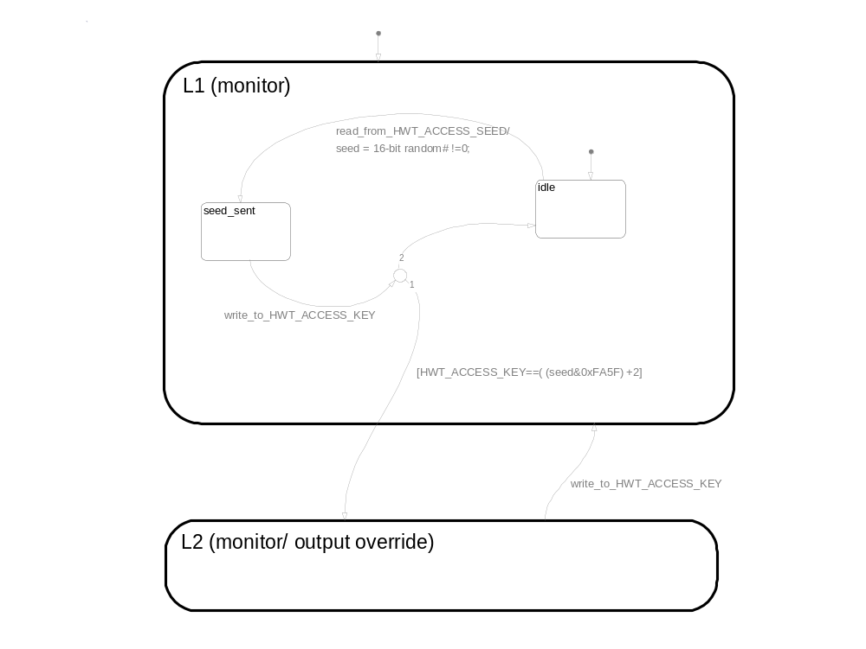Figure 1 HWT_ACCESS_LEVEL change procedure.

Access Level 2 Example

Get access level seed by reading address 0x1101 (Assuming base address = 0x1100)
Tx CAN Message ID = 0x18EFB0F9, Data = 0x07, 0x01, 0x10

Capture response
Rx CAN Message ID = 0x18EFF9B0, Data = 0x07, 0x01, 0x10, Seed LSB, Seed MSB

Calculate access Key (Seed & 0xFA5F) + 2
Example if Seed LSB = 0xEB and Seed MSB = 0x1C, Key is 0x184D

Write key to address 0x1102
Tx CAN Message ID = 0x18EFB0F9, Data = 0x0A, 0x02, 0x10,0x4D,0x18

Verify access level by reading address 0x1100
Tx CAN Message ID = 0x18EFB0F9, Data = 0x07, 0x00, 0x10

Capture response and verify level 2
Rx CAN Message ID = 0x18EFB0F9, Data = 0x07, 0x01, 0x10,0x02, 0x00

Startup Modes

The software on an ECU is composed of two independent software programs (bootblock and application). The functions in this module are responsible for transferring execution between these modules.

Bootblock software
- First thing executed out of reset.
- If application software is valid transfers control to application software with minimal hardware initialization.
- Contains software and protocol for reprogramming application software.

Reserved bootblock startup mode (bb_smode) values
DEFAULT | 0x00 | Normal operation (waits in capture window then jump to application if application software is valid).
SKIP_BOOTCODE | 0x01 | Restart controller, skipping the bootblock execution.
CAPTURED | 0x02 | Wait indefinitely in bootblock (processing bootblock protocol commands)

Application software
- Standalone program containing functionality to implement the desired ECU behavior.

Reserved application startup mode (ap_smode) values.
DEFAULT | 0x00 | Normal operation
HWT_L2 | 0x01 | Hardware I/O Test mode (L2)

CAN Loopback Function

The CAN Loopback function will send a CAN message on a selected CAN channel. If data = 0, the message will be sent on channel 1. If data = 1, the message will be sent on channel 2.
The message data will be {0x0A, HWT_CAN_LOOPBACK, HWT_FCALL_BASE (msb), 0, 0}.
The message ID will be 0x18EFF9{ECU SA} if message is sent on channel 1, or 0x18EF{ECU SA}F8 if sent on channel 2.

The example below shows the test process with ECU source address of 0xB0.
- The test device will send the command for the ECU to transmit on channel 2.
- The ECU shall transmit the message on channel 2.
- The test device shall echo the message received with the ID incremented by 1.
- The ECU shall transmit the message on channel 1.
- The test device shall verify the proper response.

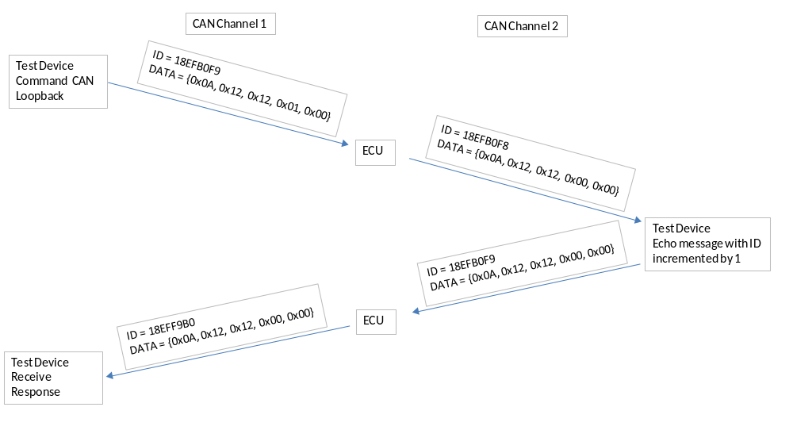
Appendix A – Channel Mapping
DIN Channels
Channel | Bank | Name
1 | 0 | HWC_DIN_NU1 (Not Used)
2 | 0 | HWC_DIN_NU2 (Not Used)
3 | 0 | HWC_DIN18
4 | 0 | HWC_DIN17
5 | 0 | HWC_DIN16
6 | 0 | HWC_DIN15
7 | 0 | HWC_DIN14
8 | 0 | HWC_DIN13
9 | 0 | HWC_DIN12
10 | 0 | HWC_DIN11
11 | 0 | HWC_DIN10
12 | 0 | HWC_DIN09
13 | 0 | HWC_DIN08
14 | 0 | HWC_DIN07
15 | 0 | HWC_DIN06
16 | 0 | HWC_DIN05
17 | 1 | HWC_DIN_LC_HSD8_DFBK
18 | 1 | HWC_DIN_LC_HSD7_DFBK
19 | 1 | HWC_DIN_LC_HSD6_DFBK
20 | 1 | HWC_DIN_LC_HSD5_DFBK
21 | 1 | HWC_DIN_LC_HSD4_DFBK
22 | 1 | HWC_DIN_LC_HSD3_DFBK
23 | 1 | HWC_DIN_LC_HSD2_DFBK
24 | 1 | HWC_DIN_LC_HSD1_DFBK

ADC Channels
Channel | Legacy Name
1 | HWC_ADC_PRECISION_REF
2 | HWC_ADC_BATT_AFBK
3 | HWC_ADC_SW_BATT_AFBK
4 | HWC_ADC_VSENSOR1_AFBK
5 | HWC_ADC_AIN08_VSENSOR2
6 | HWC_ADC_AIN11_LC_LSD1_AFBK
7 | HWC_ADC_HC_LSD1_IFBK
8 | HWC_ADC_HC_LSD2_IFBK
9 | HWC_ADC_HC_LSD3_IFBK
10 | HWC_ADC_HC_LSD4_IFBK
11 | HWC_ADC_AIN01_DIN01
12 | HWC_ADC_AIN02_DIN02
13 | HWC_ADC_AIN03_DIN03
14 | HWC_ADC_AIN04_DIN04
15 | HWC_ADC_AIN05
16 | HWC_ADC_AIN06
17 | HWC_ADC_AIN07
18 | HWC_ADC_FIN1_AFBK
19 | HWC_ADC_AIN09
20 | HWC_ADC_AIN10
21 | HWC_ADC_HC_HSD1_AFBK
22 | HWC_ADC_HC_HSD2_AFBK
23 | HWC_ADC_HC_HSD3_AFBK
24 | HWC_ADC_HC_HSD4_AFBK
25 | HWC_ADC_HC_HSD5_AFBK
26 | HWC_ADC_HC_HSD6_AFBK
27 | HWC_ADC_HC_HSD7_AFBK
28 | HWC_ADC_HC_HSD8_AFBK
29 | HWC_ADC_HC_LSD5_IFBK
30 | HWC_ADC_HC_LSD6_IFBK
31 | HWC_ADC_AIN12
32 | HWC_ADC_AIN13
33 | HWC_ADC_HC_LSD5_AFBK
34 | HWC_ADC_HC_LSD6_AFBK

FIN Channels
Channel | Legacy Name
1 | HWC_FIN1
2 | -
3 | -
4 | -

DOUT Channels
Channel | Bank | Legacy Name
1 | 0 | HWC_DOUT_HC_LSD1_CMD
2 | 0 | HWC_DOUT_HC_LSD2_CMD
3 | 0 | HWC_DOUT_HC_LSD3_CMD
4 | 0 | HWC_DOUT_HC_LSD4_CMD
5 | 0 | HWC_DOUT_HC_LSD5_CMD
6 | 0 | HWC_DOUT_HC_LSD6_CMD
7 | 0 | HWC_DOUT_NU1
8 | 0 | HWC_DOUT_NU2
9 | 0 | HWC_DOUT_LC_HSD1_CMD
10 | 0 | HWC_DOUT_LC_HSD3_CMD
11 | 0 | HWC_DOUT_LC_HSD5_CMD
12 | 0 | HWC_DOUT_LC_HSD7_CMD
13 | 0 | HWC_DOUT_DIN01_ENABLE
14 | 0 | HWC_DOUT_DIN02_ENABLE
15 | 0 | HWC_DOUT_DIN03_ENABLE
16 | 0 | HWC_DOUT_DIN04_ENABLE
17 | 1 | HWC_DOUT_LC_HSD2_CMD
18 | 1 | HWC_DOUT_LC_HSD4_CMD
19 | 1 | HWC_DOUT_LC_HSD6_CMD
20 | 1 | HWC_DOUT_LC_HSD8_CMD
21 | 1 | HWC_DOUT_CAN_TERM_OFF1
22 | 1 | HWC_DOUT_CAN_TERM_OFF2
23 | 1 | HWC_DOUT_WC_ON1
24 | 1 | HWC_DOUT_WC_ON1_AUTO
25 | 1 | HWC_DOUT_WC_ON2
26 | 1 | HWC_DOUT_WC_ON2_AUTO
27 | 1 | HWC_DOUT_WC_ON3
28 | 1 | HWC_DOUT_WC_ON3_AUTO
29 | 1 | HWC_DOUT_WC_ON4
30 | 1 | HWC_DOUT_WC_ON4_AUTO
31 | 1 | HWC_DOUT_WC_ON5
32 | 1 | HWC_DOUT_WC_ON5_AUTO
33 | 2 | HWC_DOUT_WC_ON6
34 | 2 | HWC_DOUT_WC_ON6_AUTO
35 | 2 | HWC_DOUT_WC_ON7
36 | 2 | HWC_DOUT_WC_ON7_AUTO
37 | 2 | HWC_DOUT_WC_ON8
38 | 2 | HWC_DOUT_WC_ON8_AUTO
39 | 2 | HWC_DOUT_WC_CONFIG1
40 | 2 | HWC_DOUT_WC_CONFIG1_AUTO
41 | 2 | HWC_DOUT_WC_CONFIG2
42 | 2 | HWC_DOUT_WC_CONFIG2_AUTO
43 | 2 | HWC_DOUT_WC_CONFIG3
44 | 2 | HWC_DOUT_WC_CONFIG3_AUTO
45 | 2 | HWC_DOUT_WC_CONFIG4
46 | 2 | HWC_DOUT_WC_CONFIG4_AUTO

PWM Channels
Channel | Name
1 | HWC_PWM_HC_HSD2
2 | HWC_PWM_HC_HSD4
3 | HWC_PWM_HC_HSD6
4 | HWC_PWM_HC_HSD8
5 | HWC_PWM_LC_LSD1
6 | HWC_PWM_HC_HSD1
7 | HWC_PWM_HC_HSD3
8 | HWC_PWM_HC_HSD5
9 | HWC_PWM_HC_HSD7

